**CFA 3 Corporate Issuers**

**3.1 Organizational Forms, Corporate Issuer Features, and Ownership**

**Organisational forms**

Key features of organisational forms

* If business is separate legal entity from owner
* If owners operate business
* If owners have limited or unlimited liability for the business
* Tax treatment of profits and losses
* Access to additional capital

1) Sole proprietorship

* Owned and operated by individual
* Unlimited liability
* Receives all profits and losses, taxed as personal income
* Usually small scale

2) General partnership

* Partnership agreement specifies each partners responsibilities and share of profits/losses
* Unlimited liability, profits taxed as personal income

3) Limited partnership

* Has 2 levels of partners – general partners have unlimited liability, limited partners have limited liability and claims to profits proportional to investments
* Profits taxed as personal income to partners

4) Corporation/Limited company

* Key difference from others: Is a separate legal entity from its owners
* All shareholders have limited liability
* Corporations have access to debt and equity
* Separation of owners and managers: Owners appoint a board of directors who hire managers
* Public corporation is public traded, Private corporation has restrictions on share transfers
* May face double taxation depending on the country: On earnings and dividends

**Key features of corporate issuers**

Need to file Articles of incorporation with a regulatory body to form separate legal entity

Shareholders have voting rights to elect Board of Directors

Post double taxation effective tax rate is given by:

$$\frac{Total tax paid}{Earnings before tax}$$

**Public vs private**

Most public companies are listed

* Shares on an exchange, which has price and volume transparency
* Limited company shares are not on an exchange – value hard to read, transfer is difficult

Actively traded shares are the free float

* Not held by insiders, strategic investors, or sponsors

Public companies have compliance and reporting requirements

* E.g., Quarterly reports, disclose material changes in ownership
* Private companies have fewer requirements

Private companies can raise equity capital through private placements of securities

* Typically restricted to accredited investors

Private companies can become public in 3 ways

1. IPO – investment bank underwrites issue, raises capital
2. Direct listing – doesn’t raise any capital, no need for underwriter, existing shares are listed on an exchange
3. SPAC – SPAC raises money through IPO, and puts the funds in a trust, which is later used for an acquisition in a specified time

**3.2 Investors and other stakeholders**

**Financial claims**

Debt-holders have a legal contractual claim

Equity-holders have a residual claim

* Debt is less costly than capital as it is less risky

Equity-holders have unlimited upside, whereas debt is limited to the interest and principal payments

Higher leverage can increase Return on Equity if the expected rate of return > cost of debt

Debt-holders and Equity-holders may have different goals

* Debt-holders want to avoid risk as their return is capped anyways
* Debt-holders can limit borrowers actions through Covenants – contractual provisions such as max leverage or min interest coverage ratio

**Stakeholder groups**

Shareholder theory: Primary focus of governance is the interest of the firm’s shareholders

* Maximise value of equity

Stakeholder theory is broader

Lenders can be public (bondholders) or private (private debtholders e.g., banks)

* Private debtholders may have non-public info and may also hold equity
* Bondholders have only public info and have no influence over operations

Board of directors

* Responsible for protecting shareholder interest, managing management, setting strategic direction, monitoring financial performance
* Can include inside directors (e.g., senior execs, founders), and independent directors (no relationship with company)
* Inside directors may have conflicts of interest with shareholders

Board structure

* One-tier – inside directors and independent directors all on a single board
* Two-tier – independent directors on supervisory board, inside directors on management board

Board elections

* Staggered board: Only a fraction of the board is elected each year, reduces shareholder power for major board overhaul
* Full board: Full board elected

Senior managers

* Receive salary and bonus (tied to performance)
* Interested in continued employment and maximising compensation

Human capital (employees)

* Interested in pay, career advancement, training, working conditions

Suppliers

* Interested in preserving relationship, increasing profits, firm’s solvency (they are typically short term creditors)

Customers

* Interested in quality, price, support

Government

* Interested in tax revenue, economic growth, employment, social welfare, compliance

**ESG**

ESG is important because:

* Gov stakeholders increasingly prioritise climate and social policy
* Can impact customer good will
* Fines and judgements
* Prevent senior managers exploiting shareholders
* Many young investors manage their money with ESG in mind

Environmental

* Physical risk: Effects on assets and operations from weather
* Transition risk: Gov regulations and consumer choices demand it
* Stranded assets – assets that become unviable from these changes

Social

* E.g., Protecting customer privacy, employee satisfaction, D&I, community relations
* Can increase employee productivity, lower turnover, increased customer loyalty, less litigation risk

Governance

* E.g., Compositive of the board, Internal audit committee, executive compensation, corruption, political contributions, lobbying
* Need to make sure managers act ethically, lawfully, and in shareholder interest

**3.3 Corporate Governance**

**Principal-agent**

Principal-agent: When one party hires another to do a task

Principal-agent problem: Agent’s interests may not coincide with the principal’s interests

* Agency costs are the costs created (e.g., hiring someone to monitor agent)

Conflicts can arise from information asymmetry between shareholders and managers

* Managers have more info about the functioning of the firm

Common problems

* Managers put in insufficient effort
* Managers with option grants may want to increase risk as options have no downside risk, managers who are cash compensated may avoid risk
* Manager compensation through company size may lead to empire building (unnecessary M&A)
* Managers may undertake self-dealing

**Conflicts between shareholders**

Controlling shareholders can act against the interests of minority shareholders

* E.g., May prefer diversification while minority shareholders prefer specification

Dual class structure: Some shareholders have more voting power

* Can let one group further their interests at the expense of other groups

**Conflicts between creditors and shareholders**

Shareholders prefer more business risk than creditors

* Creditors have limited upside from good results

**Managing stakeholder relationships**

Corporate governance: System of internal controls by which companies are managed

* Defines the rights and responsibilities of various groups within an organisation
* Objective: Minimise conflicts of interest

Stakeholder management: Managing company relations with stakeholders

* E.g., Annual reports, proxy statements
* Includes info about financial performance, executive renumeration, governance structure, etc

**Shareholder mechanisms**

Annual General Meeting: Held after fiscal year

* Management presents financial statements, answers shareholder questions

Shareholders can vote by proxy if they don’t attend

* Assigns right to vote for someone else
* Ordinary resolutions require a majority of votes

Extraordinary general meetings can be called at any time something requires a vote

* E.g., M&A, liquidation

Activist shareholders: Pressure companies in which they hold significant shares for changes they believe will increase shareholder value

* May initiate Proxy contest (seek proxies of other shareholders)
* May make Tender offer to gain control

Threat of Hostile takeover can be incentive for management to act in the interests of shareholders

* However pay cause management to use takeover defences instead (e.g., staggered board elections, poison pill provisions)

**Creditor mechanisms**

Bond indenture: Legal document that specifies the rights of bondholders and company obligations

* Covenants: May be included in bond indentures that require the company to take or restrict certain actions

Collateral may be used to back the bond

Creditor committees: May form among bondholders to protect interests if issuer faces financial distress

**Board of directors and management mechanisms**

Typically has committees made up of board members with particular expertise which reports to the board

* Audit committee: Oversight of financial reporting, internal audit, finding external auditor
* Nominating/Governance committee: Oversight of board elections, laws and regulations, compliance
* Compensation/Renumeration committee: Oversight of renumeration for directors and senior management
* These ones specifically are often all nonexec/independent

**Employee, customer, supplier mechanisms**

Labour laws, employment contracts, and unions are the main employee mechanisms

Employee Stock Ownership Plans – May align company and employee interests

Customers and suppliers typically use contracts as mechanisms

**Risks of poor governance**

When governance is weak, audits and board oversight is weak as well

* E.g., Accounting fraud
* Some stakeholders may gain an advantage from other stakeholders

Managers may choose sub-optimal levels of risk

Managers may pursue own benefit at the expense of the shareholders

Can lead to legal and reputational risks

Can increase default risk

**3.4 Working Capital and Liquidity**

**Cash conversion cycle**

Cash conversion cycle: Efficiency of a company’s cash flow management

Represents the time it takes to convert inventory into cash inflows from sales

* I.e., How quickly it can convert investments into cash and cash into new opportunities

$$CCC=Days of inventory on hand+Days sales outstanding+Days payable outstanding$$

Days of inventory on hand: Days it takes to sell inventory

Days sales outstanding: Days it takes to collect payment from customers

Days payable outstanding: Days it takes to pay suppliers

Lower CCC is better – less capital is in working capital

**Increasing and decreasing CCC**

CCC can be decreased by reducing inventory and receivables or increasing payables

Potential disadvantages to decreasing CCC:

* Reduced inventory of raw materials can create bottlenecks
* Reduced inventory of finished goods can lead to inability to meet demand
* Reduced credit to customers may mean lost sales

Accounts payable is an implicit source of credit from suppliers

Suppliers offer payment terms in $a/b net c$

* Firms get a discount of $a$ if they pay in $b$ days, otherwise full payment is due in $c$ days

Forgoing the discount essentially is borrowing money from the supplier for $(c-b)$ days at an effective annual rate of:

$$EAR of supplier financing={\left(1+\frac{a}{1-a}\right)}^{\left(\frac{365}{c-b}\right)}-1$$

May be more cost effective to borrow money instead of forgoing the discount

**Working capital**

Net WC is linked to CCC:

$$Total WC=Current Assets-Current Liabilities$$

$$Net WC=Current Assets \left(exc Cash and Marketable Securities\right)-Current Liabilities (exc Debt)$$

**Liquidity**

For assets, liquidity is nearness to cash

For liabilities, liquidity is nearness to settlement

For a corporate issuer, liquidity is whether cash and other liquid assets can meet short term obligations

Primary liquidity sources: Cash, marketable securities, bank borrowings

Secondary liquidity sources: Cash saved by suspending dividends, delayed capex, selling assets, issuing new equity, restructuring debt, bankruptcy filing protection

* Sends negative signals and is higher cost

Cost of liquidity is the % you lose from fair value from converting to cash quickly

Drag on liquidity: When cash inflows lag

* Excess inventory build-up, DOH increases

Pull on liquidity: When cash outflows accelerate

* Suppliers demand faster payments, DPO decreases

**Liquidity ratios**

Current ratio shows if current assets can meet current liabilities:

* > 1 means it can meet

$$Current ratio=\frac{Current assets}{Current liabilities}$$

Quick ratio takes into account how liquid the current assets are

* More stringent measure

$$Quick ratio=\frac{Cash and Marketable Securities+Accounts Receivable}{Current liabilities}$$

Cash ratio is the most stringent measure of liquidity:

$$Cash ratio=\frac{Cash and Marketable Securities}{Current liabilities}$$

**Working capital management**

Holding short term assets ensure liquidity but offer lower rates of return

Risk of not being able to roll over short term debt at reasonable cost

Conservative approach: Hold a higher proportion of short term assets, and finance working capital from longer term sources

* Benefit: High liquidity, more stable
* Cost: Higher costs, lower profitability

Aggressive approach: Hold a higher proportion of long term assets, and finance working capital from shorter term sources

Moderate approach: Permanent current assets funded using longer term capital, variable current assets funded through short term sources

**Short term liquidity sources**

Factors that affect approach to short term funding:

* Company size – smaller have limited options
* Creditworthiness – affects interest rate
* Legal systems – protections for lenders
* Regulatory concerns – some industries have restrictions on funding sources
* Underlying assets – collateral

**3.5 Capital Investments and Capital Allocation**

**Capital investment types**

4 types of capital investment

1) Going concern projects

* May be need to maintain the business or reduce costs
* Does not require detailed analysis, just if operations should continue
* Match funding – to reduce financing risk, finance projects with capital sources consistent with the project life
* Can be similar to the depreciation expense

2) Regulatory/Compliance projects

* May be required by gov agency or insurance company
* Typically generate little to no revenue

3) Expansion projects

* Grow the business – entering new markets, or introducing new products
* Requires forecasting

4) Other projects

* Investments outside existing line of business
* Can be similar to start ups, or M&A

**Capital allocation process**

Capital allocation process: Identifying and evaluating capital projects

* Involves the purchase of long term assets

4 steps:

1. Idea generation – generate good project ideas
2. Analysing project proposals – make cash flow forecast for expected profitability
3. Create capital budget – pick profitable projects which align with company resources and strategy
4. Monitor and post-audit – compare actual results with projected results, see if forecasting can be improved

**Net Present Value**

NPV: The sum of the present values of all cash flows, adjusted for the risk level of the project

$$NPV={CF}_{0}+\frac{{CF}_{1}}{{\left(1+k\right)}^{1}}+\frac{{CF}_{2}}{{\left(1+k\right)}^{2}}+…+\frac{{CF}_{n}}{{\left(1+k\right)}^{n}}$$

${CF}_{0}$ is the initial investment (negative cash flow)

$k$ is the required rate of return

* Usually the cost of capital

For independent projects, accept anything with a positive NPV

Conventional cash flow pattern: Signs on cash flows only change once

Unconventional cash flow pattern: More than one sign change or inconsistent time intervals

**IRR**

IRR: The discount rate that makes the PV of cash inflows equal the cost of the project

$$NPV=0={CF}_{0}+\frac{{CF}_{1}}{{\left(1+IRR\right)}^{1}}+\frac{{CF}_{2}}{{\left(1+IRR\right)}^{2}}+…+\frac{{CF}_{n}}{{\left(1+IRR\right)}^{n}}$$

If IRR > required rate of return, accept the project

Hurdle rate: Minimum IRR for a project to be accepted

**Advantages and disadvantages of NPV and IRR**

Advantage of NPV:

* Direct measure of expected value increase for a firm

Advantage of IRR:

* Measures profitability as a percentage

Disadvantages of IRR

* Not reasonable to assume cash flows are reinvested at the IRR (more realistic to assume reinvested at the required rate of return)
* For multiple sign changes, there are multiple IRRs which is hard to interpret

**Return on invested capital**

Return on invested capital is given by:

$$ROIC=\frac{NOPAT}{Avg book value of invested capital}$$

NOPAT is net income + after tax interest expense

Average invested capital includes long term debt and equity, but excludes working capital

ROIC can also be written as:

$$ROIC=\frac{NOPAT}{Sales}×\frac{Sales}{Avg Invested Capital}$$

$\frac{NOPAT}{Sales}$ is operating margin after tax

$\frac{Sales}{Avg Invested Capital}$ is asset turnover

If ROIC is greater than the required rate, the firm is adding value

Advantages of ROIC

* Based on accounting data
* NPV and IRR are project specific, ROIC is for firm as a whole

Disadvantages of ROIC

* Accounting treatments may differ between companies
* ROIC is backward looking
* Profitable projects may mask unprofitable ones as it is for whole company

**Principles of capital allocation**

1) Decisions are based on after-tax cash flows, not accounting income which is accrual based

2) Incremental cash flows only

* Incremental cash flows are those that change if the project is undertaken
* Should include impact on cash flows of other parts of business – e.g., cannibalisation
* Sunk costs are costs that cannot be avoided even if the project is not undertaken – these costs are not affected by the accept/reject decision, so are not included

3) Timing of cash flows are important

Common mistakes:

* Cognitive errors (calc errors) and Biases (judgement errors)

**Cognitive errors**

1) Poor forecasting (e.g., Incorrect overhead costs, or neglecting competitors

2) Not considering the cost of internal funds

* Cost of internally generated funds should be the same as cost of equity, because it would be paid as dividends if not for the project

3) Incorrectly accounting for inflation

* Need to use real discount rate for real cash flows

**Behavioural biases**

1) Pet projects of senior management

* May be overly optimistic and not scrutinised properly

2) Inertia in setting the entire capital budget

* This year’s allocation may be anchored to the previous years allocation

3) Basing investment on EPS or ROE

* May avoid long term positive NPV projects which reduce short term EPS or ROE

4) Failure to generate alternative investment ideas

* Once a good idea is generated, many stop looking for better ideas

**Real options to capital investments**

Real options: Actions that a firm can take, given that they invest in a project today

* Can be added to NPV
* Real options cannot have a negative value

Timing options: Allows a firm to delay an investment because it expects to have better info in the future

Abandonment options: Allows abandonment if PV of abandoning > PV of continuing it

Expansion options: Allows additional investments in future projects

Flexibility options: Gives choices regarding operational aspects of the project

* Price setting options (can change price of product, e.g., raise prices if demand is high)
* Production flexibility options (e.g., pay workers overtime, different input materials)

Fundamental options: Projects that are options themselves as payoffs depend on the price of an underlying asset

* E.g., Payoff for copper mine depends on the market price of copper

**3.6 Capital Structure**

**WACC**

WACC is given by:

$$WACC=Weight of Debt×Pretax Cost of Debt×\left(1-Tax Rate\right)+Weight of Equity×Cost of Equity$$

Cost of debt is typically lower than Cost of equity

Weights can be target weights or market value weights

* Target weights: Based on book value of debt and equity
* Market value weights: Reflect current market conditions

**Factors affecting capital structure**

Company characteristics that influence the proportion of debt:

* Growth and stability of revenue – growth and stability means you can service debt
* Growth and predictability of cash flow
* Business risk
* Amount and liquidity of company assets – can be used as collateral, better if tangible and liquid
* Cost and availability of debt financing

Types of companies:

* Noncyclical companies can support more debt
* Companies with low operating leverage (fixed costs as a proportion of total costs) can support more debt
* Companies with subscription based revenue models can support more debt

Stage of company life:

* Start up: Low sales, potentially negative cash flow, high business risk, low assets, financed almost entirely with equity
* Growth stage: More debt can be used
* Mature stage: Lots of debt, at relatively low cost

Cost of capital is influenced by top down factors too

* Any factors that affect the benchmark interest rate and credit spreads
* During downturns, investors demand greater yield spreads to benchmark bonds from corporate bonds

**MM Proposition 1**

Under certain conditions, the value of a firm is unaffected by capital structure

Assumptions:

* Perfectly competitive capital markets
* Investors have homogenous expectations about cash flows
* Riskless borrowing and lending
* No principal agent costs
* Investment decisions unaffected by financing decisions

MM1: The value of a firm does not depend on how the claims to its earnings are divided

* The amount of pie does not depend on how it is sliced
* WACC is the same regardless

**MM Proposition 2**

Uses the same assumptions as MM1

MM2: The cost of equity increases linearly as a company increases its proportion of debt financing, as the risk of cash flows to equity holders increases

* WACC is the same regardless of the cap structure

The cash flows to bondholders have priority over equity

* The greater the debt, the more uncertain the residual cash flows to equity holders

Any decrease in financing costs from using more lower-cost debt is offset by the increase in the cost of equity

* Results in no change in WACC

MM2 equation is given by:

$$r_{e}=r_{0}+\frac{D}{E}\left(r_{0}-r_{d}\right)$$

$r_{e}$ is the cost of equity

$r_{0}$ is the cost of equity with no debt

$r_{d}$ is the cost of debt

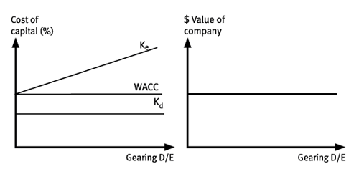

**MM2 with no taxes**

New assumption: Earnings are taxed, and interest payments to debtholders are tax deductible

Debt provides a tax shield that adds value to the company

* Encourages debt financing
* The value of the levered firm is equal to the value of the unlevered firm + the value of the tax shield

MM2 with taxes is given by:

$$r_{e}=r_{0}+\frac{D}{E}\left(r_{0}-r_{d}\right)(1-T_{C})$$

$T_{C}$ is the tax rate

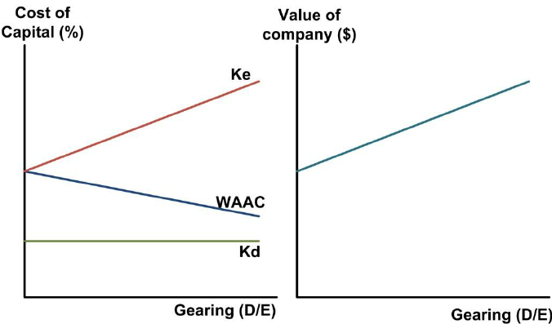

MM says the optimal amount of debt is 100% debt

* Different investor tax rates on dividends and interest could explain capital structure differences
* This is not seen in reality

**Financial distress - Debt costs not considered by MM**

There are also other debt financing costs not considered by MM

* Costs of financial distress are higher at higher debt levels

Financial distress: When cash flows can’t meet interest payments

1) Can be direct and indirect

* Direct: Cash expenses
* Indirect: Foregone investment opportunities, losing trust, conflicts of interest between managers and debtholders (agency costs of debt)

2) Probability of financial distress

* Higher leverage increases the probability of distress

High expected costs of financial distress discourage companies from using lots of debt

**Static trade-off theory**

Static trade-off theory: Balance the costs of financial distress with the tax shield benefits from using debt

* Gives the Optimal capital structure 🡪 WACC is minimised

The value of a levered firm is given by:

$$V_{L}=V_{U}+\left(t×Debt\right)-PV(Costs of financial distress)$$

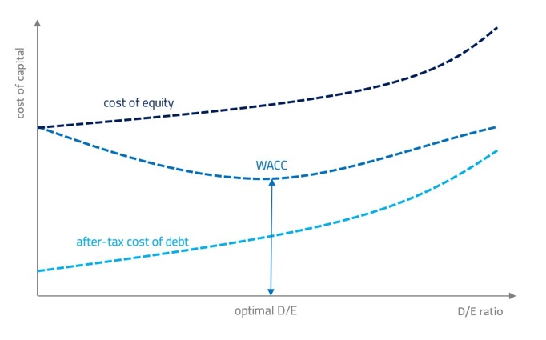

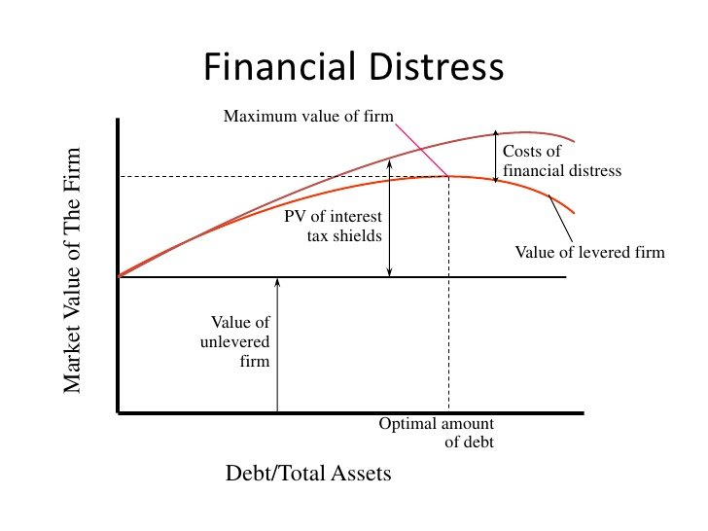

**Target capital structure**

Target capital structure is what a firm seeks to achieve on average over time

For analysis, the weights for WACC should be based on target capital structure

* Since management don’t provide these, an analyst must estimate this themselves – can use existing marker value, trends, or industry average

Company managers often focus on book values of debt and equity instead of market value

* Market values fluctuate and do not reflect appropriate levels of debt
* Credit agencies use book values

Market fluctuations make the actual capital structure fluctuate around the target

* Management may be opportunistic for when they raise capital – e.g., raise equity when the stock is high

**Asymmetric information**

Managers have more info about a company’s future performance than creditors

* If managers take commitment to pay interest, then it signals they are confident in future ability to pay debt
* If managers issue equity, it can be a negative signal as managers think stock is overvalued

**Agency costs of equity**

Shareholders try to reduce the principal agent problem

Net agency cost of equity: The cost of reducing the principal agent problem

3 components

* Monitoring costs – supervising managers, reporting to shareholders
* Bonding costs – make sure managers are working in the best interest of shareholders (e.g., premiums for performance)
* Residual losses – losses that occur anyways

**Free cash flow hypothesis**

FCF hypothesis: Use of debt forces management to be disciplined with cash spending, as they have less FCF for their own benefit

**Pecking order theory**

Pecking order theory: Due to informational asymmetry managers prefer to make financing choices that are least likely to send negative signals to investors

* Internally generated capital is most preferred
* Debt is next
* External equity is last

**3.7 Business Models**

**Key features of business models**

Business model: How we provide it, sell it, and make a profit

1) Who: Identify the potential customers

* How to acquire, cost of acquisition, what they want

2) How: Key assets and suppliers of the firm

3) What: Firm’s product or service

* How it meets customer needs, how it differentiates from competitors

4) Where: How will the firm sell

* AKA Channel strategy

5) How much: Pricing strategy

**Pricing strategies**

Commodity producers are price takers as they have undifferentiated products

* Need differentiated products for pricing power

Price discrimination examples:

* Tiered pricing: Based on volume
* Dynamic pricing: Depending on demand levels
* Value pricing: Pricing on quality
* Auction pricing

Pricing models for multiple products

* Bundling – when products are complementary
* Razors and blades – sell a piece of equipment for a low price, and make profits from a consumable used with it
* Add-on pricing – add-ons after the product has been purchased already

Other pricing models

* Penetration pricing – offer product cheap to gain share and accelerate growth
* Freemium – free product with unlocks for a cost
* Hidden revenue – free content, but with ads

Models with no outright purchases

* Subscriptions
* Licensing and franchising

**Value proposition and Value chain**

Value proposition: How customers will value the product/service given competing products and their prices

Value chain: Comprises the assets of the firm and how it adds value and exploits competitive advantage

* Includes the product quality, functionality, service that is included, sale process, pricing relative to competition

**Other business models**

Private label manufacturers/Contract manufacturers

* Produce products for others to market under their own brand name

Licensing agreements

* Company’s brand is used by another on its products for a fee

Value-added resellers

* E.g., installation, service, support, customisation for custom equipment

Network effects

* Increase in value of the network as user base grows

Crowdsourcing

* Benefit from user contributions